REV. |  | Description |  |  |  |  |  | Date
00 |  | SPEC ISSUE (NEW MODEL)  ADP-65JW Y2A |  |  |  |  |  | 12/11’20
01 |  | 102A-211065  ITEM 13.Loop gain 測試  Disturbance voltage setting 從0.4V變更為0.3V |  |  |  |  |  | 01/15’21
02 |  | 102A-212052  1. 更新 ITEM 13. Loop/Gain 測試作業規範 圖片說明。  2. ITEM 6.Function test (ATS) procedure： (15VDC)  Test Item: Sync Dynamic(only for 15V), 增加 CPK 不計算。  3. ITEM 7.Function test (ATS) procedure： (9VDC)  Test Item: Sync Dynamic(only for 9V), 增加 CPK 不計算。 |  |  |  |  |  | 02/17’21
03 |  | 102A-213123  ADD MODEL: ADP-65JW X2A, ADP-65JW Z2A |  |  |  |  |  | 03/17’21
04 |  | 102A-215085  新增 ITEM 14.OVP 測試作業說明 |  |  |  |  |  | 05/14’21
05 |  | 102A-21B098  ITEM 14.OVP 測試作業說明 change to 14. Stress OVP 測試作業說明  更改串聯電阻 to 220歐姆 |  |  |  |  |  | 11/12’21
06 |  | 102A-222047  新增 ITEM 3.i EMI測試已under 6db做判定。 |  |  |  |  |  | 02/15’21
07 |  | 102A-235337  ADD MODEL: ADP-65JW Y2C |  |  |  |  |  | 06/01’23
08 |  | 102A-238054  ITEM 9.1 Hi-POT test:  “Cut off current : Hi-Limit 10mA, Lo-Limit 0.02A” change to “Cut off current : 10mA” |  |  |  |  |  | 08/07’23
09 |  | 102A-241328  ADD MODEL: ADP-65JW Y2B |  |  |  |  |  | 02/19’24
10 |  | 102A-244163  1. ITEM 3. 測試注意事項  add j. 噪音測試熱機, 以該輸出電壓熱機做熱機測試 (FOR ADP-65JW Y2B)  2. ITEM 4. 手調測試站 e.OVP test: add  測試5V OVP 時, 從輸出外灌7.3V電壓測試OVP (FOR ADP-65JW Y2B)  測試9V OVP 時, 從輸出外灌13V電壓測試OVP (FOR ADP-65JW Y2B) |  |  |  |  |  | 04/17’24
11 |  | 102A-245164  ADD MODEL: ADP-65JW Y2D, ADP-65JW Z2C |  |  |  |  |  | 05/15’24
 |  |  |  | 台達電子工業股份有限公司  DELTA ELECTRONICS, INC. |  |  | DESCRIPTION :  測試注意事項 (Test Specification )
 | THESE DRAWINGS AND SPECIFICATIONS ARE THE PROPERTY OF DELTA  ELECTRONICS, INC. AND SHALL NOT BE REPRODUCED OR USED AS THE  BASIS FOR THE MANUFACTURE OR SELL OF APPARATUSES OR DEVICES  WITHOUT PERMISSION. |  |  |  |  |  | MODEL NO. :  ADP-65JW X2X SERIES
 | Date |  | Drawn |  | Design (EE) | Design (ME) | DOCUMENT NAME. :  TS-65JW X2X SERIES |  | REV.
 | 05/15’24 |  | 王玉玲 |  | 陳俊宇 | 陳俊豪/張伯毅 |  |  | 11
FRAME NAME: DF-PSLA4V-2R01.DOC SHEET 2 OF 15

MODEL LIST
MODEL NAME | TYPE
ADP-65JW Y2A/Y2B/ Y2C/Y2D | US
ADP-65JW X2A | CN
ADP-65JW Z2A/ Z2C | EU

- 測試注意事項內容，未經工程師許可，不可任意變更。
Test Notice contents shall not be changed or revised without engineer permission.
- 此測試規格用於主線測試,所有項目均需被測試,因設備或線速限制無法全數測試時, 需測試worst case, QC需按抽樣標準測試所有Item不可只測試主線測試項目.
The production line shall perform all or worst test items/conditions, and QC shall follow the sampling plan to perform all items/conditions not just the worst condition as production did.
- 測試注意事項 :
  - 功能測試時,電子負載需設定Von點為3V.
  - 所有ATS測試時，須偵測CONNECTOR端之電壓。
  - 在測試及崩應時，治具上各組輸出須有加系統電容。
  - All function test輸出並聯電容 100uF/25V。
  - Open frame或是Case未組裝前的各項測試,於測試完成後須對BULK CAP放電
  - No Load測試，輸出端不接測試治具且只測試輸出5V的條件
  - 手機干擾測試以5cm條件測試與判定。
  - AC on/off 負載設定為 CR mode.
  - EMI測試已under 6db做判定。
  - 噪音測試熱機, 以該輸出電壓熱機做熱機測試 (FOR ADP-65JW Y2B)

- 手調測試站：(以下為範例寫法請依據產品特性自行修正)
  - VR調整測試條件如下: N/A
  - Full Load Test：檢查滿載輸出是否符合規格
  - Min. Load Test：檢查輕載輸出是否符合規格
  - OTP Test :
Load Condition : 20V/3.25A 15V/3A 9V/3A 5V/3A
測試方法：NTC131並聯4.99Kohm電阻，檢查輸出電壓是否Latch off。
  - OVP Test :
Load Condition : 0A
短路R134, OVP動作模式為Latch off.
Vout | OVP
5 | 7.5V
9 | 13.5V
15 | 20.25V
20 | 27V

測試5V OVP 時, 從輸出外灌7.3V電壓測試OVP (FOR ADP-65JW Y2B)
測試9V OVP 時, 從輸出外灌13V電壓測試OVP (FOR ADP-65JW Y2B)

  - AC On/Off:
Power supply 連續開關機 On= 5秒, Off= 5 秒, 5 次後, 必須無損壞情形。(必加項目)
- Function test (ATS) procedure： (20VDC)
Input Specification Table:
INPUT VOLTAGE | MINIMUM | MAXIMUM | NOMINAL(RATED)
LOW RANGE | 90 VAC | 132 VAC | 100 VAC
HIGH RANGE | 180V AC | 264V AC | 240V AC

Output Specification Table:
20V/3.25A on-off transient Vo no damage
OUTPUT | MINIMUM | MAXIMUM | NOMINAL(RATED)
Voltage (Vdc) | 19 | 21 | 20
Loading (Amp) | 0 | 3.25 | 3.25

Test Item | Vin | Load | Spec | Remark
Hold up Time | 100V/50Hz | 3.25A | ≥5ms
Power saving requirement | 115V/60Hz  230V/50Hz | 18W  11W  5W~6.5W  3W  1.65W  1.5W  1W  0.25W | <21W  <14W  Eff.>80%  <5W  <3W  <2.2W  <1.6W  <0.48W
Line Regulation | 90/264V 47/63Hz | 3.25A | 19~21V
Line Regulation | 90/264V 47/63Hz | 0A | 19~21V
Ripple & Noise | 90V/47Hz 264V/63Hz | 20V/3.25A | ≤300mVp-p | 0.1uF//10uF  Oscilloscope at 20MHz bandwidth.25℃
Surge Load  (only for 20V) | 100V/50Hz 240V/50Hz | Output 3.25A(1s) to 3.9A(1s) | Vo >18.5V | At 25℃.
Sync Dynamic  (only for 20V) | 90V/47Hz 264V/63Hz | Output 0.05A to 3.25A Slew rate is 2.5A/us. Frequency is 100Hz~100KHz. | 19~21V
Short Circuit Protection | 90V/47Hz 264V/63Hz | Min. Load  Turn on then short | Latch | 重啟方式  Plug or CC re-plug or  ATE控制板同時送入2組CC訊號可reset PD IC
Over Current Protection | 90V/47Hz 264V/63Hz | 20V/ 3.25A | OCP is  3.9A~5.0A  Latch | 重啟方式  Plug or CC re-plug or  ATE控制板同時送入2組CC訊號可reset PD IC
Input Current | 100V /50Hz | 20V/ 3.25A | Iin, max <1.5A
Full Load Efficiency | 100V/50Hz  240V /50Hz | 20V/ 3.25A | >84.0% | Cold
Average Efficiency | 115V/60Hz  230V/50Hz | 25%, 50%, 75% & 100% Load | >85% for 20V | Cold
10% Load | 115V/60Hz  230V/50Hz | 20V / 0.325A | >77.85% | Cold
Full Load Efficiency | 100V/50Hz  240V /50Hz | 20V/ 3.25A | >86.0% | Hot
Average Efficiency | 115V/60Hz  230V/50Hz | 25%, 50%, 75% & 100% Load | >89.00% for 20V | Hot
10% Load | 115V/60Hz  230V/50Hz | 20V / 0.325A | >78.85% | Hot
Capacitive Load | 100V/50Hz | 20V / 3.25A |  | Parallel 1000uF Cap at output
Output change and discharge time | 100V/50Hz  240V/50Hz | No load  Full load | 0~275mS
Peak Load | 100V/50Hz  240V/50Hz | Output 2.925A to 7.000A 18ms/2ms | >17.8V
Peak Load | 100V/50Hz  240V/50Hz | Output 2.844A to 7.313A 2.25ms/0.250ms | >17.8V

- Function test (ATS) procedure： (15VDC)
Input Specification Table:
INPUT VOLTAGE | MINIMUM | MAXIMUM | NOMINAL(RATED)
LOW RANGE | 90 VAC | 132 VAC | 100 VAC
HIGH RANGE | 180V AC | 264V AC | 240V AC

Output Specification Table:
15V/3A on-off transient Vo no damage
OUTPUT | MINIMUM | MAXIMUM | NOMINAL(RATED)
Voltage (Vdc) | 14.25 | 15.75 | 15
Loading (Amp) | 0 | 3 | 3

Test Item | Vin | Load | Spec | Remark
Line Regulation | 90/264V 47/63Hz | 3A | 14.25~15.75V
Line Regulation | 90/264V 47/63Hz | 0A | 14.25~15.75V
Ripple & Noise | 90V/47Hz 264V/63Hz | 15V/3A | ≤300mVp-p | 0.1uF//10uF  Oscilloscope at 20MHz bandwidth 25℃.
Surge Load  (only for 15V) | 100V/50Hz 240V/50Hz | Output 3A(1s) to 3.6A(1s). | Vo >13.7V
Sync Dynamic  (only for 15V) | 90V/47Hz 264V/63Hz | Output 0.05A to 3A. Slew rate is 2.5A/us. Frequency is 100Hz~100KHz. 50% duty. | 14.25~15.75V | CPK 不計算。
Short Circuit Protection | 90V/47Hz 264V/63Hz | Min. Load  Turn on then short | Latch | 重啟方式  Plug or CC re-plug or  ATE控制板同時送入2組CC訊號可reset PDIC
Over Current Protection | 90V/47Hz 264V/63Hz | 15V / 3A | OCP is  3.9~5.0A  Latch | 重啟方式  Plug or CC re-plug or  ATE控制板同時送入2組CC訊號可reset PDIC
Input Current | 100V /50Hz | 15V / 3A | Iin, max <1.5A
Full Load Efficiency | 100V/50Hz  240V /50Hz | 15V / 3A | >84.0% | Cold
Average Efficiency | 115V/60Hz  230V/50Hz | 25%, 50%, 75% & 100% Load | >85% for 15V | Cold
10% Load | 115V/60Hz  230V/50Hz | 15V / 0.3A | >77.85% | Cold
Full Load Efficiency | 100V/50Hz  240V /50Hz | 15V / 3A | >86.0% | Hot
Average Efficiency | 115V/60Hz  230V/50Hz | 25%, 50%, 75% & 100% Load | >88.85% for 15V | Hot
10% Load | 115V/60Hz  230V/50Hz | 15V / 0.3A | >78.85% | Hot
Capacitive Load | 100V/50Hz | 15V / 3A |  | Parallel 1000uF Cap at output
Output change and discharge time | 100V/50Hz  240V/50Hz | No load  Full load | 0~275mS
Peak Load | 100V/50Hz  240V/50Hz | Output 2.700A to 6.000A 18ms/2ms | >13V
Peak Load | 100V/50Hz  240V/50Hz | Output 2.625A to 6.750A 2.25ms/0.250ms | >13V

- Function test (ATS) procedure： (9VDC)
Input Specification Table:
INPUT VOLTAGE | MINIMUM | MAXIMUM | NOMINAL(RATED)
LOW RANGE | 90 VAC | 132 VAC | 100 VAC
HIGH RANGE | 180V AC | 264V AC | 240V AC

Output Specification Table:
9V/3A on-off transient Vo no damage
OUTPUT | MINIMUM | MAXIMUM | NOMINAL(RATED)
Voltage (Vdc) | 8.55 | 9.45 | 9
Loading (Amp) | 0 | 3 | 3

Test Item | Vin | Load | Spec | Remark
Line Regulation | 90/264V 47/63Hz | 3A | 8.55~9.45V
Line Regulation | 90/264V 47/63Hz | 0A | 8.55~9.45V
Ripple & Noise | 90V/47Hz 264V/63Hz | 9V/3A | ≤200mVp-p | 0.1uF//10uF  Oscilloscope at 20MHz bandwidth.25℃  不計算CPK。
Sync Dynamic  (only for 9V) | 90V/47Hz 264V/63Hz | Output  0A to 1.5A, 295ms/5ms  Output  1.5A to 3A, 25ms/5ms | 8.55~9.45V | 1A/us slew rate  CPK 不計算。
Short Circuit Protection | 90V/60Hz  264V/50Hz | Min. Load  Turn on then short | Latch | 重啟方式  Plug or CC re-plug or  ATE控制板同時送入2組CC訊號可reset PDIC
Over Current Protection | 90V/60Hz  264V/50Hz | 9V / 3A | OCP is  3.1A~3.6A  Latch | 重啟方式  Plug or CC re-plug or  ATE控制板同時送入2組CC訊號可reset PDIC
Full Load Efficiency | 100V/50Hz  240V /50Hz | 9V / 3A | >83% | Cold
Average Efficiency | 115V/60Hz  230V/50Hz | 25%, 50%, 75% & 100% Load | >85% for 9V | Cold
10% Load | 115V/60Hz  230V/50Hz | 9V / 0.3A | >76.3% | Cold
Full Load Efficiency | 100V/50Hz  240V /50Hz | 9V / 3A | >84% | Hot
Average Efficiency | 115V/60Hz  230V/50Hz | 25%, 50%, 75% & 100% Load | >87.3% for 9V | Hot
10% Load | 115V/60Hz  230V/50Hz | 9V / 0.3A | >77.29% | Hot
Capacitive Load | 100V/50Hz | 9V / 3A |  | Parallel 100uF Cap at output
Output change and discharge time | 100V/50Hz  240V/50Hz | No load  Full load | 0~275mS

- Function test (ATS) procedure： (5VDC)
Input Specification Table:
INPUT VOLTAGE | MINIMUM | MAXIMUM | NOMINAL(RATED)
LOW RANGE | 90 VAC | 132 VAC | 100 VAC
HIGH RANGE | 180V AC | 264V AC | 240V AC
Output Specification Table:
5V/3A on-off transient Vo no damage
OUTPUT | MINIMUM | MAXIMUM | NOMINAL(RATED)
Voltage (Vdc) | 4.85 | 5.5 | 5
Loading (Amp) | 0 | 3 | 3

Test Item | Vin | Load | Spec | Remark
Inrush Current | 264V/50Hz; | 3.0A | No damage | Cold /Hot start
Turn On Time | 100V/50Hz 240V/50Hz | 3.0A | ≤ 3s.
Rise Time | 100V/50Hz 240V/50Hz | 3.0A | <40ms | From 10 to 90% voltage, monotonic
Line Regulation | 90/264V 47/63Hz | 3A | 4.85~5.5V
Line Regulation | 90/264V 47/63Hz | 0A | 4.85~5.5V
Ripple & Noise | 90V/47Hz 264V/63Hz | 5V/3A | ≤180mVp-p | 0.1uF//10uF  Oscilloscope at 20MHz bandwidth.25℃  不計算CPK。
Sync Dynamic  (only for 5V) | 90V/47Hz 264V/63Hz | Output  0A to 1.5A, 295ms/5ms  Output  1.5A to 3A, 25ms/5ms | 4.6~5.8V | 1A/us slew rate
Short Circuit Protection | 90V/47Hz 264V/63Hz | Min. Load  Turn on then short | Latch | 重啟方式  Plug or CC re-plug or  ATE控制板同時送入2組CC訊號可reset PDIC
Over Current Protection | 90V/47Hz 264V/63Hz | 5V / 3A | OCP is  3.1A~3.6A  Latch | 重啟方式  Plug or CC re-plug or  ATE控制板同時送入2組CC訊號可reset PDIC
Full Load Efficiency | 100V/50Hz  240V /50Hz | 5V / 3A | >77% | Cold
Average Efficiency | 115V/60Hz  230V/50Hz | 25%, 50%, 75% & 100% Load | >79.4% for 5V | Cold
10% Load | 115V/60Hz  230V/50Hz | 5V / 0.3A | >71.48% | Cold
Full Load Efficiency | 100V/50Hz  240V /50Hz | 5V / 3A | >78% | Hot
Average Efficiency | 115V/60Hz  230V/50Hz | 25%, 50%, 75% & 100% Load | >81.84% for 5V | Hot
10% Load | 115V/60Hz  230V/50Hz | 5V / 0.3A | >72.48% | Hot
Pin at No Load | 115V/60Hz  230V/50Hz | No Load | ≤0.075W | 輸出端不可接到負載
Capacitive Load | 100V/50Hz | 5V / 3A |  | Parallel 100uF Cap at output
Note 1: After completes required DVT test matrix, identifies and selects the worst case condition for the Production MTR. It is not required that all test conditions be tested. Example: If worst case condition for Output Ripple is minimum input voltage and maximum dc load, then that is the test condition to be used.

- Safety
  - Hi-POT test：
Primary to Secondary use 3000+10% Vac. (Rise time：DC=1Sec, AC=0.1Sec)
Cut off current : 10mA
Note: Testing time for production line is 1 minute at EVT/DVT stage and 1 Second at PVT/MP stage. Following is Arcing sense setting at each stage : EVT1: 5mA, EVT2/DVT: 8mA, PVT/MP: 10mA
  - Insulation Resistance (IR) test :
The insulation resistance shall be not less than 30M ohms after application of 500Vdc/10mA for 1 minute.
  - Earth Grounding test : N/A
  - Leakage current :
Leakage current no more than 20uA(max) at 240Vac/50Hz.for delta product line.
  - EMI and RFI:
RFI Set up:
- Wall mount用插座測試, DC線不可與AC線接觸
- 依下圖所示使用1m長AC延長線, AC線按法規規章自然下垂於地板
- 詳細擺設如下圖示意
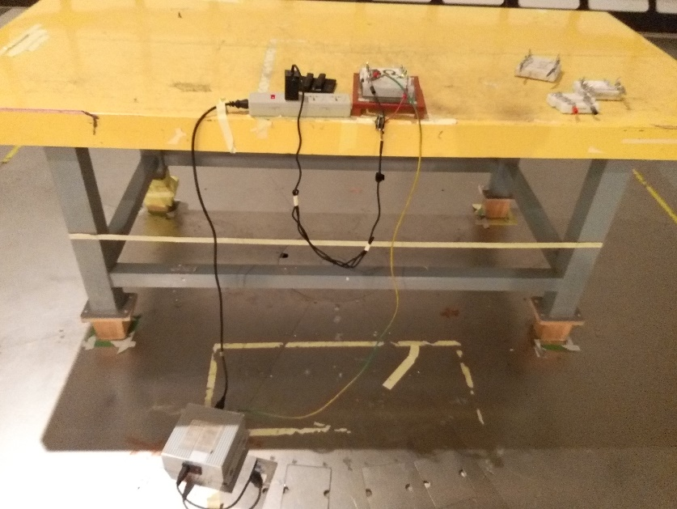
  - Thermal Test:
Wall mount用插座站立測試.

- Burn-in 測試作業規範
5V 6 Hrs
9V 6 Hr
15V 6 Hr
20V 6 Hrs

- I2C 測試作業規範：N/A

- FRU Data Barcode Read/Write 測試作業規範：N/A

- Loop/Gain 測試作業規範
Disturbance voltage setting 0.3V
Phase margin > 45deg.
Gain margin > 6db
R132 紅色區域斷開,串接20ohm再接回 Vout，如右下圖所示
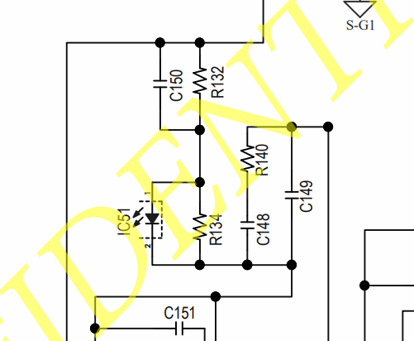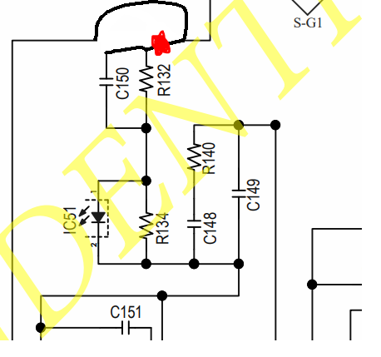
- Stress OVP 測試作業說明
OVP 測試方式，從photo coupler 第1隻腳拉出並串聯一開關與一220歐姆電阻，至二次測接地，並用開關測試OVP，如下圖。
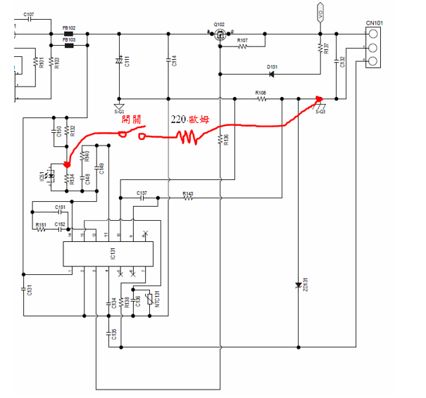

- ESD 測試作業規範
±15KV air discharge performance criterion B.
±12KV air discharge performance criterion A.
±8KV contact discharge performance criterion A.
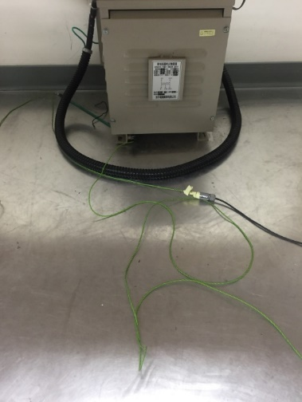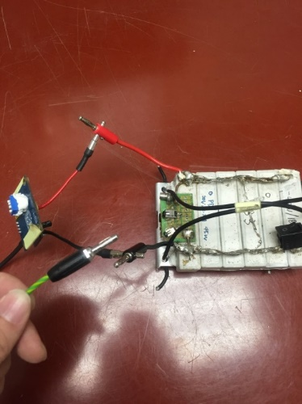
ESD槍每次對負載釋放能量時，負載的地(Vo-)都必須與電源系統的設備地接觸一次

- Pin assignment
